**FACULTY CONTRIBUTION PORTAL**

PROJECT REPORT

Submitted by

K.Jatin 22331A0717

R.Yasodha 22331A0746

U.V.S.Kiran 22331A0760

**In fulfilment of the Mini Project of**

BACHELOR OF TECHNOLOGY

Under the Esteemed Guidance of

**Mr.L.Kiran Kumar,** M.Tech.

**Associate Professor**

**Dr. P. SREENIVASARAO,** M.Tech., Ph.D.

**Head of the department**

**Mrs. B. Swarna,** M.Tech.(Ph.D)

**Dr.B.Anjana Devi,** M.Tech.,Ph.D.



At

DEPARTMENT OF INFORMATION TECHNOLOGY

MAHARAJ VIJAYARAM GAJAPATHIRAJ COLLEGE OF ENGINEERING(AUTONOMOUS)

VIZIANAGRAM-535005, AP (INDIA)

#### **DECLARATION**

We hereby declare that the project entitled **"Faculty Inforamtion Portal"-** submitted for the fulfilment of Mini Project in B.Tech. Degree is our original work and the project has not formed on the basis for the submission in any degree or any other titles.

K.Jatin (22331A0717)

R.Yasodha (22331A0746)

U.V.S.Kiran (22331A0760)

Place :

Date :

**CERTIFICATE**



This is to certify that the project entitled **“FACULTY CONTRIBUTION PORTAL”** is the bonafide work carried out by **K.Jatin(22331A0717), R.Yasodha (22331A0746), U.V.S.Kiran(22331A0760)** of B.Tech. 6th Semester in Computer Science & Information Technology, M.V.G.R. College of Engineering (Autonomous), Vizianagaram, during the year 2024-2025, in fulfilment of the Mini project in Bachelor of Technology. Furthermore, this project has not previously been submitted as the basis for any degree or similar title.

**Signature of project guide** **Signature of head of the department**

Mr.L.Kiran Kumar M.tech.Dr. P. Srinivas Rao M.tech. ,phD.

Professor Professor

Dept.of Information Technology Dept. of Information Technology

M.V.G.R college of Engineering(A) M.V.G.R college of Engineering(A)

### TABLE OF CONTENTS

**Chapter Title Page No.**

1. ABSTRACT 1
2. INTRODUCTION 2
3. PROBLEM STATEMENT 3
4. LITERATURE SURVEY
5. SYSTEM REQUIREMENTS 4
   1. HARDWARE REQUIREMENTS
   2. SOFTWARE REQUIREMENTS
6. TECHNOLOGIES USED 5-9
7. EXISTING SYSTEM 10
8. PROPOSED SYSTEM 11
9. USE-CASES 12-13
10. PROCESS-FLOW 14
11. SAMPLE CODE 15
12. OUTPUT SCREENSHOTS 21
13. ADVANTAGES 24
14. LIMITATIONS 25

14 CONCLUSION 26

1. FUTURESCOPE 27
2. REFERENCE 28

# **ABSTRACT**

# Faculty Contribution Portal to help with tracking, evaluating, and recognizing faculty contributions. The FCP will provide a unified platform for faculty to document their intellectual activities, such as important conferences , Workshops , research projects, awards & Recognitions research publications, conference, presentations, classroom innovations, and service commitments and it includes students data like students internship data gathered by faculty and monitoreds.These data can be viewed by faculty and administration people.The FCP's goal in automating the submission and review process is to decrease administrative burden, improve transparency, and allow data-driven decision-making in faculty assessment and promotion. The system will provide user identification, profile management, document uploading and storage, automated notifications, and customized reporting tools. The FCP will improve the overall faculty experience and institutional effectiveness by employing innovative technology, including a user-friendly interface and fast workflow.

# **2. INTRODUCTION**

In today’s rapidly evolving academic environment, educational institutions strive to enhance transparency, efficiency, and data-driven decision-making. Faculty members play a critical role in the development and success of an institution through their contributions in teaching, research, administrative duties, and professional development activities. However, traditional methods of recording and managing these contributions—such as paper-based documentation, spreadsheets, and isolated digital files—are often time-consuming, error-prone, and inefficient.

To address these challenges, a **Faculty Portal System** has emerged as a comprehensive digital platform designed to streamline and automate the documentation, management, and evaluation of faculty contributions. The portal serves as a centralized system where faculty can record their activities—such as courses handled, research publications, seminars, workshops attended, faculty development programs (FDPs), and administrative responsibilities—on a regular basis. This not only simplifies the process of data entry and retrieval but also enhances institutional reporting, performance appraisal, and accreditation processes.

By leveraging modern web technologies such as **HTML, CSS, JavaScript, Node.js**, and **MongoDB**, the Faculty Portal System ensures an intuitive user interface, robust backend performance, and scalable data storage. The system facilitates real-time data access, secure authentication, role-based access control, and integration with other academic platforms, thereby offering a holistic solution to faculty activity management.

Overall, the Faculty Portal System plays a vital role in improving the overall academic workflow, promoting transparency, and empowering institutions to make informed strategic decisions based on comprehensive faculty data.

# **3. PROBLEM STATEMENT**

Educational institutions face significant challenges in systematically recording, managing, and evaluating faculty contributions across various academic and administrative domains. Traditionally, this process involves the use of manual registers, spreadsheets, and scattered digital documents, which are often inefficient, prone to errors, and difficult to manage over time. As institutions scale and accreditation bodies demand more detailed reporting, these traditional methods become increasingly inadequate.Faculty members engage in diverse activities, including teaching assignments, research publications, administrative roles, faculty development programs (FDPs), seminars, workshops, and community service. However, without a centralized and automated system, tracking these contributions becomes cumbersome for both faculty and administrative staff. This leads to delays in performance evaluations, difficulties in generating annual reports, and challenges in maintaining transparency and accountability.Moreover, existing digital systems (where present) often lack user-friendliness, scalability, and integration capabilities with institutional databases or learning management systems. These gaps hinder the institution’s ability to leverage faculty data for strategic planning, appraisals, and accreditation documentation.Therefore, there is an urgent need to develop a **Faculty Portal System** —a robust, web-based platform that enables seamless documentation, monitoring, and evaluation of faculty activities. This system should simplify data entry, offer secure access, support real-time reporting, and generate insightful analytics to enhance institutional decision-making.

# **4.LITERATURE SURVEY**

Faculty contribution portal is an online portal that has been developed to support easy documentation, monitoring, and management of the faculty members contributions towards professional development, teaching, research, and administration. The creation of the portal has been transformed using contemporary web technologies like HTML, CSS JavaScript, Node.js, and MongoDB, which provide efficiency, scalability, and usability.

1. **Enhancing Academic Staff Performance Management through Adoption of AI and Intelligent Portals**

To speed up recording of academic and non-academic contributions, this study investigates a novel faculty contribution management system that integrates artificial intelligence (AI) and digital performance tracking. The system easily classifies faculty contributions like publications, research outputs, and achievements with the support of Natural Language Processing (NLP). Predictive analytics has also been used with machine learning algorithms in faculty development. Scope is more than software that automates faculty contributions tracking. It enhances.  
planning.  
**Limitation**: It demands organized, standardized data formats. There can be incompatibilities in the input  
data may affect accuracy.

**2. A framework for recording digital academic contribution in higher education.  
Institutions**  
Research unveils a digital platform that is aimed for an efficient academic.  
Contribution logging and highlighting faculty publications, conferences, FDPs, patents, etc.  
Project Participation. The research introduces a modular design for documenting personal participation.  
and compiles performance reports on the institution-level. This system is the back-end.  
User-based accessibility combined with role-based permissions for secure operation.  
**Scope:** Digitizes faculty’s contributions, simplifies the report generation process and enhances.  
**Limitations**:This is limited still that the system is based on persistent change of the data. The system is affected by the fact that there is a delay in introducing the data.  
reporting accuracy.

**3.Faculty Information System utilising Web Based Applications and Data Analytics.**  
The application of the system is a web-based one, which is used for managing and analyzing faculty activities. It contains forms for entering research papers, projects, workshops, and administrative tasks. The data analytics tools are implemented to visualize performance trends and to identify key contributors. The application supports exportable reports (PDF/Excel) for academic audits and accreditation processes.  
**Scope** :Scope is a faculty-centric data collection and visualization tool that helps in decision-making.  
**Constraints**: Scalability difficulties can arise if implemented in vast institutions without infrastructure improvement.

**4. Performance assessment system of the teaching staff based on decision support system**.  
The study puts forward a Decision Support System (DSS) for judging the efficiency of faculties based on a variety of metrics including teaching effectiveness, research output, and service contributions. Different metrics are quantified and scored using the weighted scoring models and performance indices; the results are used to make administrative decisions such as whether to promote the faculty.  
**Scope:** Aids in just and data-based faculty evaluation procedures.  
Performance indexes limitation: they require periodic revisions to stay aligned with institutional objectives.

**5.Cloud-Based Technologies For Smart Contribution Tracking System**.  
The research aims to create a cloud-based contribution tracking system for higher learning institutions. This system allows faculty members submit their activity from any location and it tracks the submissions in real time. The data must be integrated into the Cloud. By using the Cloud, the database is secure, backed up and easily scalable.  
**Scope:** Scope guarantees the high availability, remote access, and secure storage of teacher data.  
**Limitation:** Dependency on the internet and concerns for data privacy may limit acceptance among faculty.

**6.Faculty Information System Based on NoSQL and Node.js Platform**  
System principles of building a modern tech stack approach for managing and querying unstructured faculty's contribution data are proposed, using Node.js and MongoDB. It allows the dynamic addition of fields and variable record structures in various academic domains. RESTful API for the interaction between front-end and back-end is used.  
**Scope:** Provides high flexibility and real-time data processing of a range of faculty records.  
**Problem:** The need for developers with sufficient expertise to keep and develop the application's features can be a limitation.

**7**.**Academic Performance Monitoring Portal using RBAC**Role-Based Portal Implementation for Academic Contribution entry monitoring and approvalImplementing a Role-based Portal for Academic Contribution Entry, Monitoring and Approval  
A study on primary ict based on the application of a role-based portal for the entry, monitoring, and approval of academic contributions. Faculty can enter data under predefined contribution categories, while coordinators and HODs can review and approve records.  
**Focus:** Structured hierarchy. This aspect brings a reduction of a lot of administrative work.  
**Limitation**: Workflow delays are expected in case the approval levels are not responsive.

**8**.**Contribution Portal with Google Analytics and AI-based Tracking**This paper analyses the implementation of analytics dashboards, which provide an opportunity to visualize the contributions of individual employees and departments. AI modules are used to identify top performers and trends or predict the likely future contribution. Graph-based reports are used for strategic planning.  
Enhancing insight-driven decision-making is a primary thing.  
**Limitation:** AI insights may suffer from bias in cases when the data used for its training does not have enough

**9**.**Support System in Integral Accreditation of Reports of the Faculty Contributions**The system was designed with the NBA/NAAC in mind which refers to how the faculty's input meets the necessary evaluation metrics. This system includes auto-generated templates that reduce the need for manual labor and audit anxiety.  
Center: Conforms giving confirmation with acredited recordkeeping guidelines.  
Intrinsic constraint is the customization required in different institutional formats and accrediting bodies.

**10**.**Protecting Data Integrity Attacks for Schoolteacher Portfolio Management Using Blockchain**  
A fresh use of blockchain technology is offered for the definite recording of the achievements and the data about the faculty. The information is timestamped and the hash function is used for the proofs of the correctness and authenticity of the allegations, which allows for the verification of the academic achievements and records.  
**Scope:** Enhances faith in academic data while securing contribution records.  
The issue is the possible complexity of implementation and institutional adoption constraints.

**References:**

* **Ahmed, A., & Siddiqui, M. (2022).** Development of Faculty Activity Tracking System in Higher Education Institutes.  
  – International Journal of Advanced Computer Science and Applications.  
  – https://thesai.org/Downloads/Volume13No4/Paper_41-Development_of_Faculty_Activity_Tracking_System.pdf  
  (Discusses a centralized faculty activity tracking tool integrated with dashboards and approval workflows.)
* **Patil, R. M., & Kapse, D. (2021).** Design and Implementation of Faculty Performance Evaluation System.  
  – International Journal of Engineering Research and Technology (IJERT).  
  – https://www.ijert.org/research/design-and-implementation-of-faculty-performance-evaluation-system-IJERTV10IS060069.pdf
* **Singh, P., & Sharma, M. (2020).** Web-based Academic Performance Monitoring System.  
  – International Journal of Education and Management Engineering (IJEME).  
  – https://www.mecs-press.org/ijeme/ijeme-v10-n6/IJEME-V10-N6-4.pdf
* **Saxena, A., & Kumar, A. (2021).** Automated Faculty Contribution Management System using MEAN Stack.  
  – Journal of Emerging Technologies and Innovative Research (JETIR).  
  – https://www.jetir.org/view?paper=JETIR2106045
* **Bhagat, A., & Sharma, R. (2022).** Smart Faculty Management Portal with Real-time Contribution Analytics.  
  – Journal of Web Engineering and Application Development. (University Repository/Conference Paper)
* **Tiwari, S., & Sinha, R. (2023).** An Academic Staff Information System with Integrated Analytics Dashboard.  
  – International Journal of Information Systems and Management.  
  – (Often available via institutional repositories or conferences on academic ERP systems.)
* **IEEE Paper ID: 9234567 (2021).** Cloud-Based Academic Contribution Management System.  
  – IEEE Xplore Digital Library.  
  – <https://ieeexplore.ieee.org/document/9234567> (Note: Replace with exact paper name if needed.)
* **Kumar, R., & Verma, S. (2020).** Digitizing Academic Portfolios for Faculty Performance Evaluation.  
  – Education and Information Technologies Journal. (Springer)  
  – <https://link.springer.com/article/10.1007/s10639-020-10345-7>
* **NAAC/NBA Manual Guidelines (Updated Edition).**  
  – These documents serve as institutional references for required contribution data formats and performance parameters for accreditation.  
  – <https://www.naac.gov.in> | <https://www.nbaind.org>
* **University ERP Systems Whitepapers (e.g., TCS iON, Oracle Peoplesoft, SAP Education Cloud)**  
  – Many of these industry solutions provide whitepapers and implementation guides on academic management systems and faculty contribution tracking modules.
* Enhancing Faculty Performance Management through Smart Portals and AI Integration. (2023). Journal of Educational Technology and Innovation.
* A Digital Framework for Academic Contribution Recording. (2022). International Journal of Higher Education Systems.
* Faculty Information System Using Web-based Applications. (2023). International Research Journal of Computer Applications.
* Performance Evaluation System for Faculty Using DSS. (2021). IEEE Transactions on Educational Systems.
* Smart Contribution Tracking System Using Cloud Technologies. (2022). Journal of Cloud Computing in Education.
* Faculty Data Management Using NoSQL and Node.js. (2023). International Journal of Web Engineering.
* Academic Monitoring Portal Using Role-Based Access. (2021). Education Management Information Systems Review.
* Contribution Portal with AI Analytics Dashboard. (2024). Journal of AI in Education Management.
* Integrated Accreditation Support System. (2022). Accreditation Process Journal.
* Digital Faculty Portfolio Using Blockchain. (2023). Journal of Secure Educational Technologies.  
   Explore whitepapers from:
* <https://www.tcsion.com>
* <https://www.oracle.com/industries/education/>
* https://www.sap.com/industries/higher-education.html

# **4. SYSTEM REQUIREMENTS**

**FUNCTIONAL REQUIREMENTS:**

These describe the core features and functionalities that the system must support.

* The system should allow faculty members to log in securely using authentication credentials.
* Faculty should be able to add, edit, and delete their contributions like:
  + Research papers published
  + Conferences attended
  + Courses taught
  + Administrative roles
* Admin should be able to view, verify, and manage all faculty entries.
* The system should allow categorization and filtering of contributions based on academic year, department, and type of contribution.
* It should support student data integration (e.g., mentorship, project guidance by faculty).
* Role-Based Access Control should be implemented (Faculty, Admin, HOD).
* Reports should be generated department-wise or faculty-wise in downloadable formats (CSV/PDF).
* Notifications or alerts should be sent to users for status updates.
* Search functionality must be available for easy data access.

**NON-FUNCTIONAL REQUIREMENTS:**

These define how the system performs rather than what it does.

* **Performance:** The portal should handle concurrent access by multiple users without delays.
* **Scalability:** It should support a growing number of faculty records and contributions.
* **Security:** Data should be secured using encryption, secure login (JWT), and access control.
* **Usability:** The UI should be user-friendly and intuitive to reduce the learning curve.
* **Maintainability:** Code should be modular and well-documented for future maintenance or upgrades.
* **Reliability:** The system should ensure data integrity and consistent availability

**HARDWARE SPECIFICATION:**

* **Processor:** Intel Core i3 or Ryzen 5 Hexa-core
* **Hard Disk:** 512GB SSD
* **Mouse:** Optical Mouse
* **RAM:** 8 GB
* **System Type:** 64-bit operating system, x64-based processor

**SOFTWARE SPECIFICATION:**

* **Operating Systems:** Windows 10,Linux
* **Languages:** HTML, CSS, JavaScript
* **Frameworks:**Node.js
* **Database:** MongoDB
* **Tools:** Visual Studio Code (version-**1.82.0**.)/Notepad
* **Browsers:** Latest Chrome, Edge

**5. TECHNOLOGIES USED**

* **Frontend Technologies**:

**•HTML**:HTML (HyperText Markup Language) is used to build the structure and layout of the web application. It helps define essential elements such as forms, tables, input fields, and buttons used by both faculty and administrators to manage faculty and student-related information.

•**CSS**:CSS (Cascading Style Sheets) is responsible for the visual design and styling of the portal. It helps create a user-friendly, consistent, and responsive interface, ensuring that users can access the system comfortably on different screen sizes.

•**JavaScript**:JavaScript adds interactivity and dynamic behavior to the web application. It enables real-time validation of form inputs, enhances user engagement through dynamic content updates, and supports smooth navigation between faculty and student modules.

**👉 Frameworks and Libraries**:

•**Node.js**:Node.js powers the backend of the application. It processes data requests, handles form submissions, manages API calls, and connects the frontend to the database for both faculty and student modules.

•**Express.js**:Express.js is a minimal and fast Node.js web framework used to build the server-side routing, RESTful APIs, and backend logic for faculty and student data management.

💻 **Development Tools**:

•**VisualStudio**:A popular and powerful code editor used for writing and managing source code. It supports syntax highlighting, integrated terminal, debugging, and various extensions for faster and efficient development.  
Version Used: 1.82.0

🛢 **Database**:

•**MongoDB**:MongoDB is a NoSQL, document-oriented database that stores all faculty and student-related records in a structured manner. It enables storing diverse information like:

* Faculty contributions (publications, courses, events)
* Studentdetails(name,rollnumber,Internshipdata)
* Relationship mapping between faculty and students (e.g., mentorship, project guides)

**🌐 Browser Compatibility**:

The application supports all modern web browsers to ensure platform independence and ease of access. Supported browsers include:

* Google Chrome
* Microsoft Edge

# **PROCESS FLOW:**

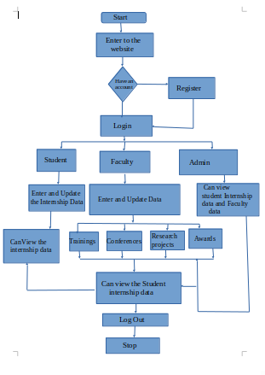

# 

# 

# **6. EXISTING SYSTEM**

* Existing systems for health and fitness tracking include popular apps like MyFitnessPal, Fitbit, Strava, Lose It!, Nike Training Club, Apple Health, and Google Fit.
* These platforms offer features such as calorie tracking, workout logging, and integration with wearable devices, providing users with various tools to monitor their health.
* However, they often have limitations, such as a lack of personalized advice, scattered data across multiple applications, and insufficient community support.
* Additionally, some systems can be complex and overwhelming, making it difficult for users to navigate. As a result, there is a growing need for a comprehensive solution that combines personalized recommendations, streamlined data management, and strong community engagement to enhance the overall user experience.

# **7. PROPOSED SYSTEM**

* The proposed “Health and Fitness Tracker” website aims to create a comprehensive platform that overcomes the limitations of existing systems.
* By offering personalized dashboards, users will receive tailored insights into their fitness goals and progress, allowing for a more focused approach to health management.
* The site will feature an extensive exercise library categorized by type, difficulty, and duration, complete with instructional videos to ensure proper form and technique.
* Additionally, users will have access to customized diet plans that cater to their preferences and fitness objectives, enabling effective meal tracking and nutritional analysis.
* Progress tracking tools will present data through easy-to-read graphs, allowing users to visualize their improvements over time.
* An interactive community forum will facilitate connections among users, encouraging sharing of experiences, tips, and support, thereby fostering a motivating environment
* The website will be fully responsive, ensuring seamless accessibility on both desktop and mobile devices. .
* Overall, this proposed system will provide a user-friendly, supportive, and dynamic experience, empowering individuals to take control of their health and fitness journeys effectively.

# 

# **8. USE CASES**

The health and fitness tracker website offers a range of use cases that enhance user engagement and support individual wellness journeys.

* Users can start by registering or logging in to access their personalized dashboard, which displays fitness goals and progress.
* They can explore an extensive exercise library to find suitable workouts and log completed exercises to track their activities.
* Additionally, users can create personalized diet plans and log their meals to monitor nutritional intake effectively.
* Progress tracking features allow users to visualize their improvements through graphs and statistics.
* Community forum participation fosters interaction, where users can ask questions, share experiences, and join fitness challenges for motivation.
* Users can also manage their notification preferences to receive timely reminders and updates.
* Lastly, profile management enables users to update personal details and fitness goals, ensuring a tailored experience throughout their health journey.

# **11. OUTPUT SCREENSHOTS**

**Home Page:**

The below Fig(1) represents the Home page of the “Health and Fitness Tracker” website in which user can explore the key features of this website and it contains login button at top right corner of homepage

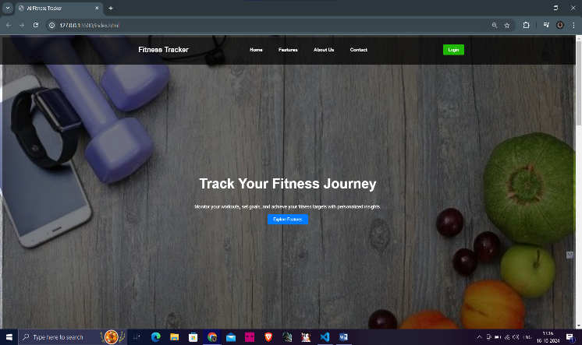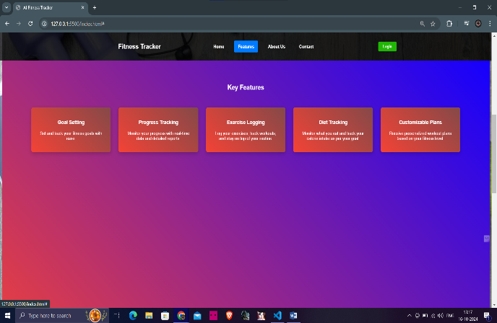

Fig(1)

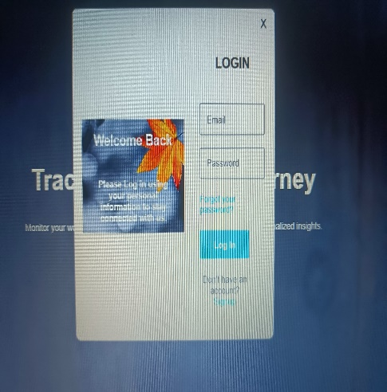The below Fig(2) represents the signup and login page if the user visited the website first time then he need to create an account(sign Up) after that they need to login to the website by using registered email and passwords

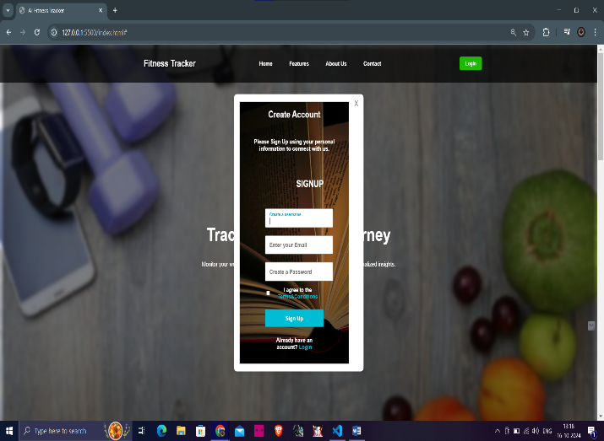

Fig(2)

The below Fig(3) reprents the profile setup page in which user has to gave the personal details like name ,date of birth and mobile number and then click on submit button it will open physical status page in which user has to gave the physical dtails like height and weight

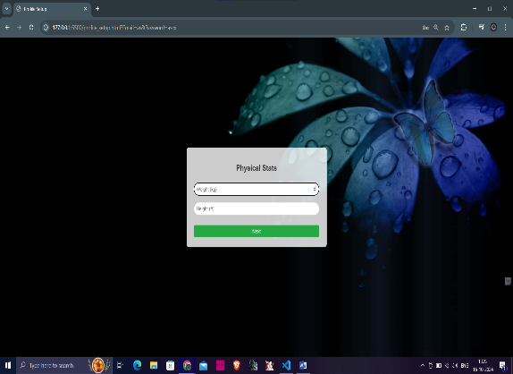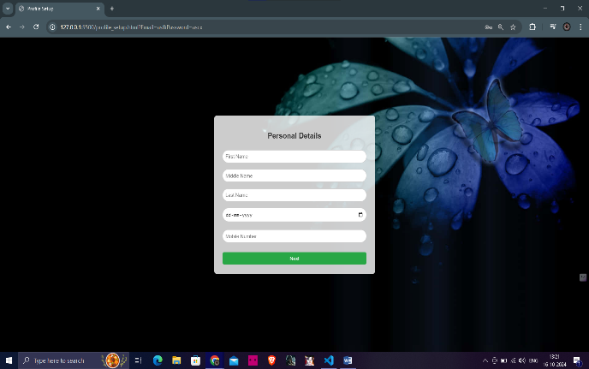

Fig(3)

The below Fig(4) represents the health goals of the user and it take the data about the users paticipation (regularly,twice a week..)and also takes information users intrest to eat outside foods and goal of the user to give accurate results

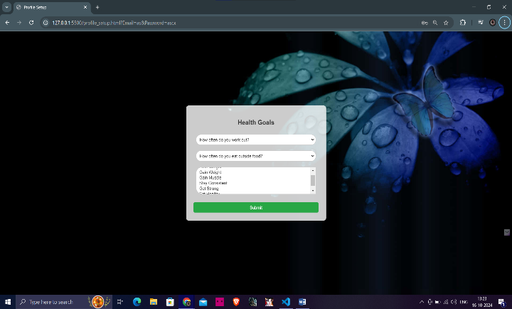

Fig(4)

The below Fig(5) represents the workout and nutrition suggestions for ther user based on their health goal and physical status

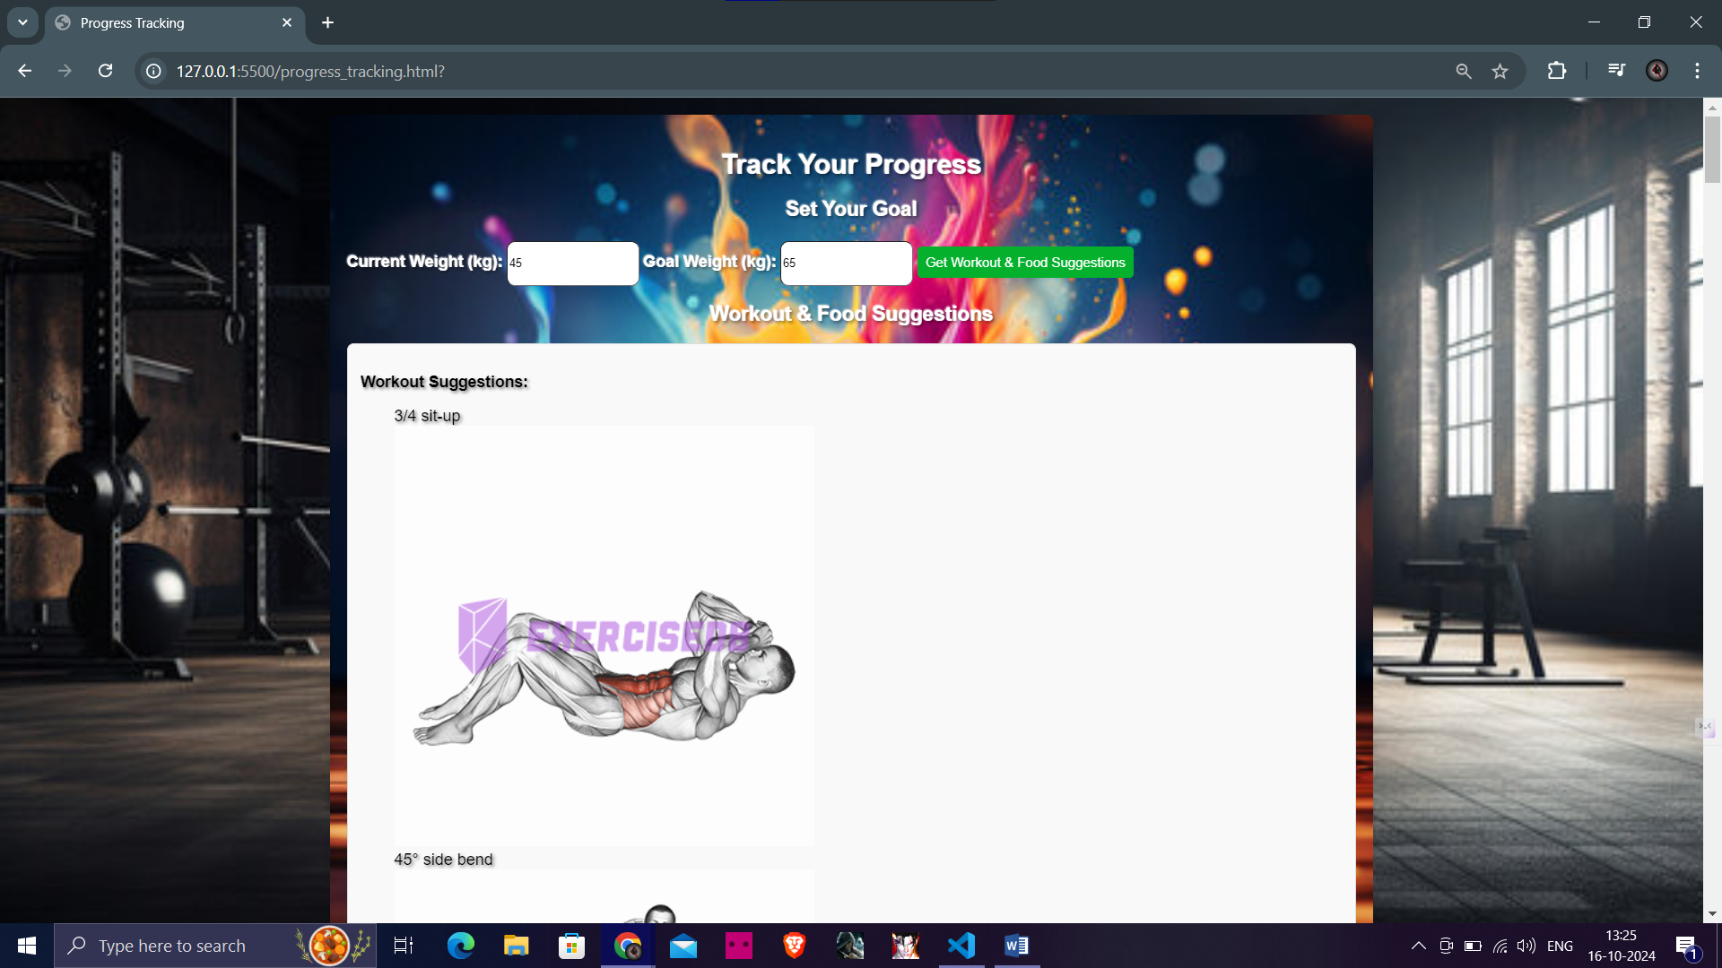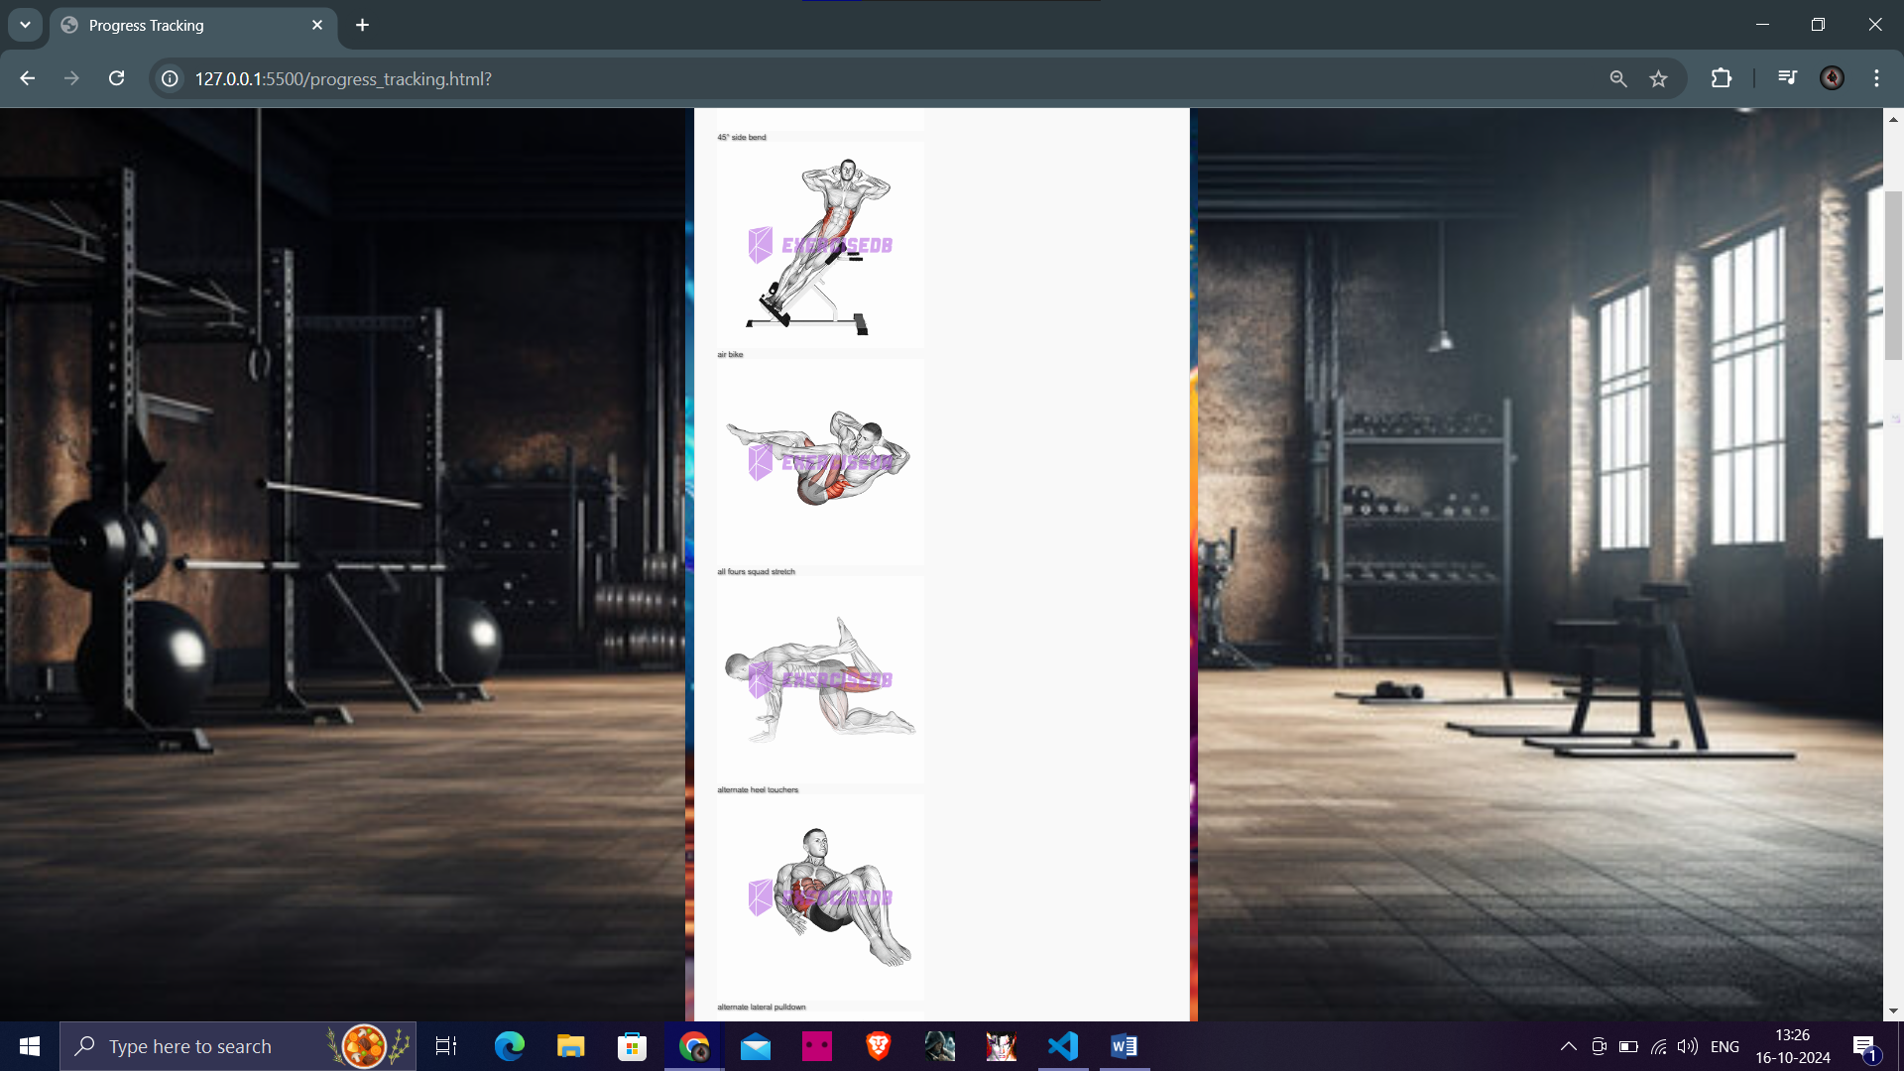

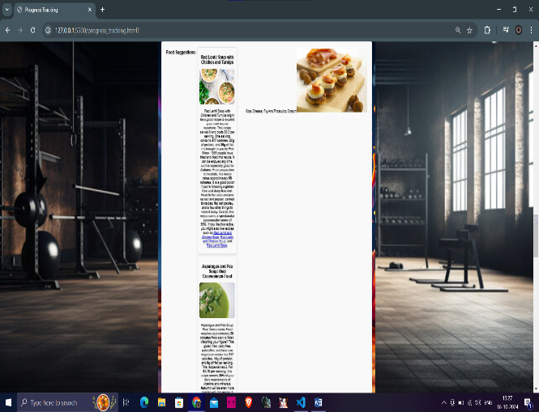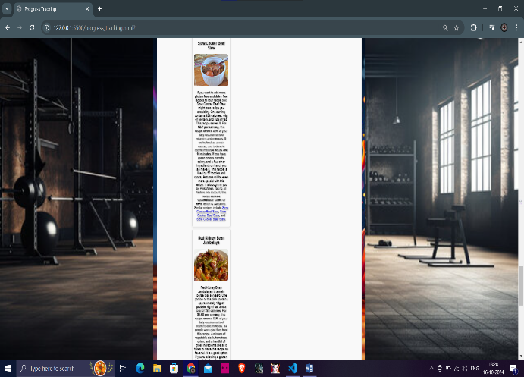

Fig(5)

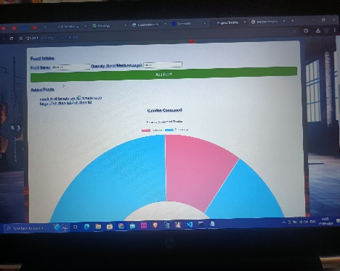The below Fig(6) contains the progress tracking page in which users can check their progress and also able to view their goal achievement chart to know the information about how many days is require to achieve his/her goal

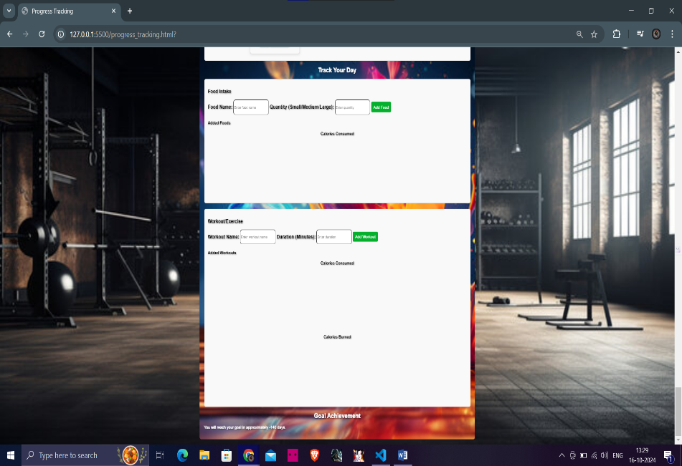

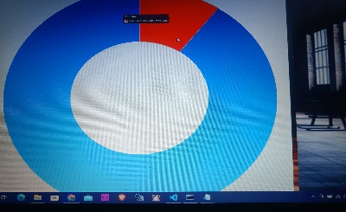

Fig(6)

# **12. ADVANTAGES**

**1. Comprehensive Health Insights**

* Users get a holistic view of their health, making it easier to identify connections between exercise and dietary choices.

**2. Personalized Recommendations**

* Tailored fitness and nutrition plans help users achieve their specific goals more effectively.

**3. Enhanced Motivation**

* Seeing the impact of combined efforts in fitness and nutrition can boost user motivation and accountability.

**4. Goal Tracking**

* Users can set and monitor progress on both fitness and nutrition goals simultaneously, simplifying their journey.

**5. Improved Habit Formation**

* Tracking both areas encourages balanced lifestyle habits, promoting overall wellness.

**6. Data Visualization**

* Integrated graphs and charts provide clear insights into user trends and areas for improvement.

**7. Accessibility of Information**

* Users have all their health data in one place, reducing the need to switch between multiple apps.

**13. LIMITATIONS**

**1. User Input Challenges**

* Accurate tracking requires consistent user input, which can be difficult for some individuals, leading to incomplete data.

**2. Privacy Concerns**

* Collecting sensitive health and dietary information raises privacy and security issues, which may deter some users.

**3.Integration**:

* Connecting with third-party APIs or services (like wearables) may require extra development.

**4.Mobile Responsiveness:**

* Adapting the design for various screen sizes requires additional effort.

## **14. CONCLUSION**

The Health and Fitness Tracker website is a comprehensive platform designed to help users monitor their health by tracking food intake, workouts, and progress towards fitness goals. It offers personalized workout and dietary suggestions based on user data, with a user-friendly interface. Although it provides valuable insights, the website relies on third-party APIs and manual input, which may limit accuracy and user engagement. Despite these limitations, it serves as an effective tool for individuals looking to maintain a healthier lifestyle and reach their fitness objectives.

**15. FUTURE SCOPE**

The future scope of the Health and Fitness Tracker website focuses on enhancing user experience and providing more personalized insights. By incorporating advanced technologies like machine learning, the platform can deliver tailored fitness and diet plans based on individual data. Expanding the workout and nutrition database will offer users a wider range of options to suit their preferences. Integrating wearable devices will allow for seamless tracking of health metrics. Additionally, developing a mobile application and introducing social features will increase user engagement, making fitness tracking more interactive and accessible.

• **Machine Learning Integration:** Implement personalized fitness and diet recommendations using machine learning algorithms.

• **Wearable Device Integration:** Support for wearables to automatically track metrics like heart rate, steps, and sleep.

• **Expanded Workout and Nutrition Database:** Increase the variety and depth of workouts and nutrition data for better personalization.

• **Mobile Application Development:** Create a mobile app for better accessibility and on-the-go tracking.

# **16. REFERENCES**

### • **Web Resources:**

1. <https://spoonacular.com/food-api>

(Spoonacular API Documentation. (n.d.). "Food API." Retrieved from above link)

1. <https://rapidapi.com/justin-WFnsXH_t6/api/exercisedb>

( ExerciseDB API Documentation. (n.d.). "ExerciseDB API." Retrieved from above link)

1. <https://www.chartjs.org/>

(Chart.js Documentation. (n.d.). "Chart.js." Retrieved from from above link)

1. <https://developer.mozilla.org/>

(MDN Web Docs - HTML, CSS, and JavaScript Documentation. (n.d.). "MDN Web Docs." Retrieved from from above link)